Overview:
We’re going to continue practicing our queries and get a little more advanced. But the end of this exercise you should be comfortable querying a MongoDB database.

Recommended studies:
Similar to the previous assignment you’ll want to look at the following commands and functions, they will help you answer the queries below, you can (and will) also use commands from the previous assignment.
Term | Description
\ (escape character) | Used to treat special characters (like * or ?) as literal characters within a query or regular expression.
^ | A regex anchor used to match the beginning of a string.
* | A wildcard character in regex that matches zero or more occurrences of the preceding character.
$or | Performs a logical OR operation on an array of one or more expressions and selects documents that satisfy at least one.
$in | Matches any of the values specified in an array.
$nin | Matches none of the values specified in an array.
$not | Inverts the effect of a query expression and returns documents that do not match the query expression.
ISODate() | A built-in function used to wrap a date string to create a Date object in MongoDB.
$regex | Provides regular expression capabilities for pattern matching strings in queries.
$mod | Performs a modulo operation on the value of a field and selects documents with a specified result.
$type | Selects documents where the value of the field is an instance of a specified BSON type.
$options | Used with $regex to specify additional flags, such as "i" for case-insensitivity.
$exists | Matches documents that have the specified field, including documents where the field value is null.

Required Assignment - MongoDB – Queries 2
Provide the commands that would answer the following queries:
Part A: Regex and Comparison Queries
- Write a MongoDB query to find the restaurant Id, name, borough and cuisine for those restaurants which contain 'Wil' as first three letters for its name.
Query: db.restaurants.find({name: /^Wil/}, {restaurant_id: 1, name: 1, borough: 1, cuisine: 1})
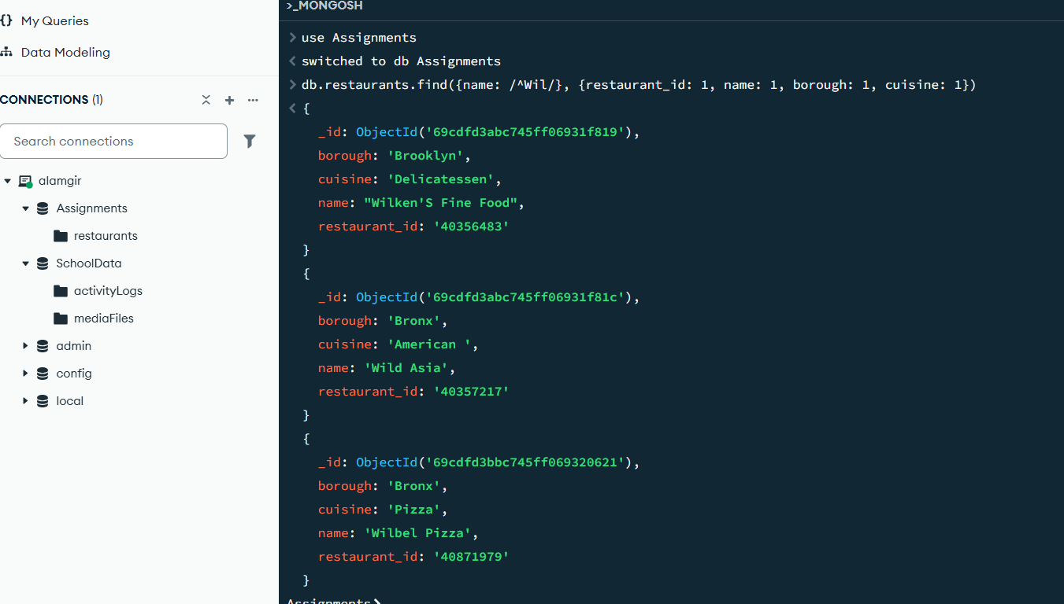

- Write a MongoDB query to find the restaurant Id, name, borough and cuisine for those restaurants which contain 'ces' as last three letters for its name.
Query: db.restaurants.find({name: /ces$/}, {restaurant_id: 1, name: 1, borough: 1, cuisine: 1})
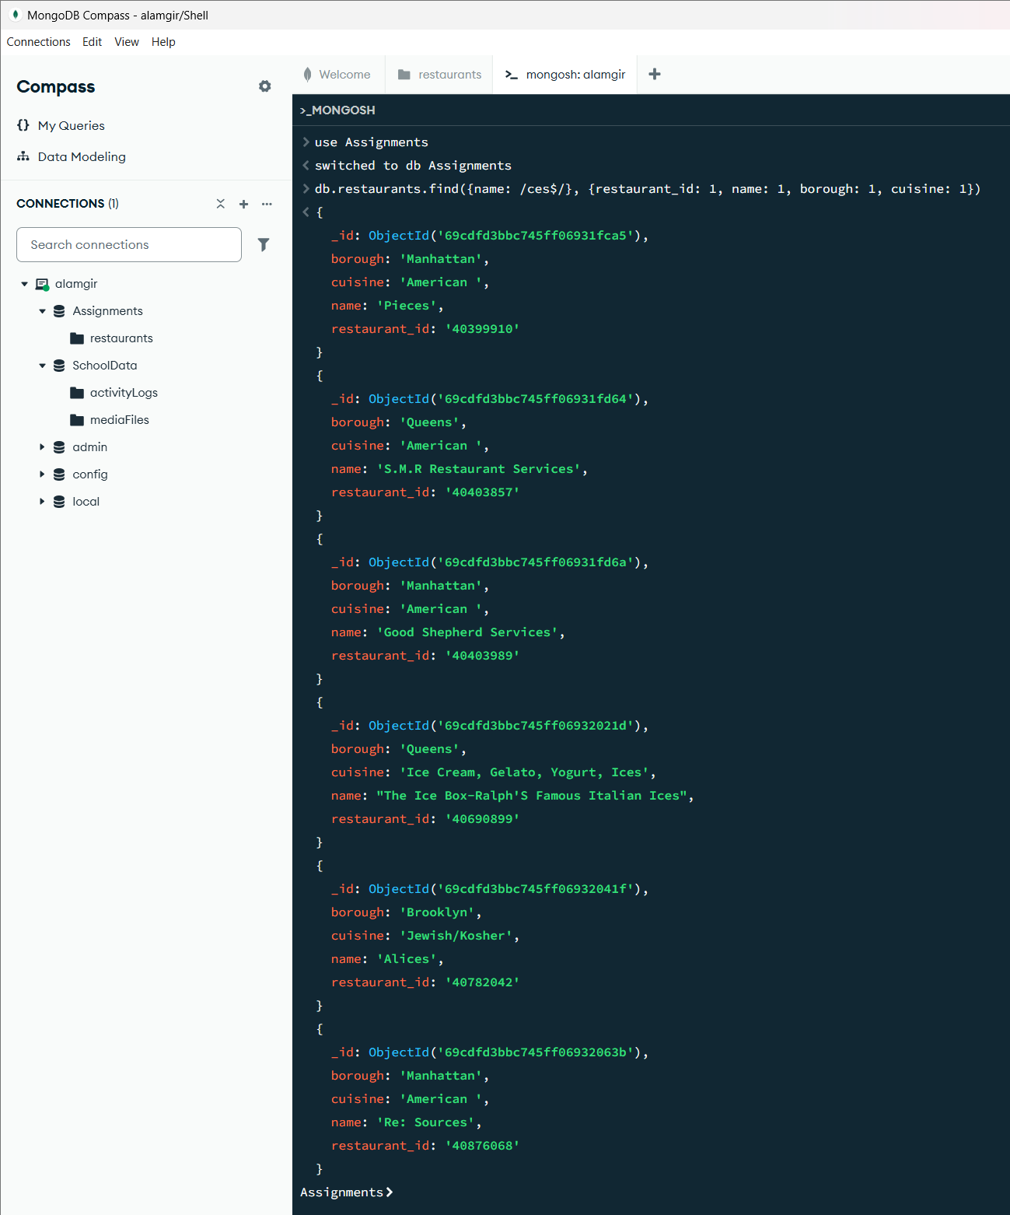

- Write a MongoDB query to find the restaurant Id, name, borough and cuisine for those restaurants which contain 'Reg' as three letters somewhere in its name.
db.restaurants.find({name: /Reg/}, {restaurant_id: 1, name: 1, borough: 1, cuisine: 1})
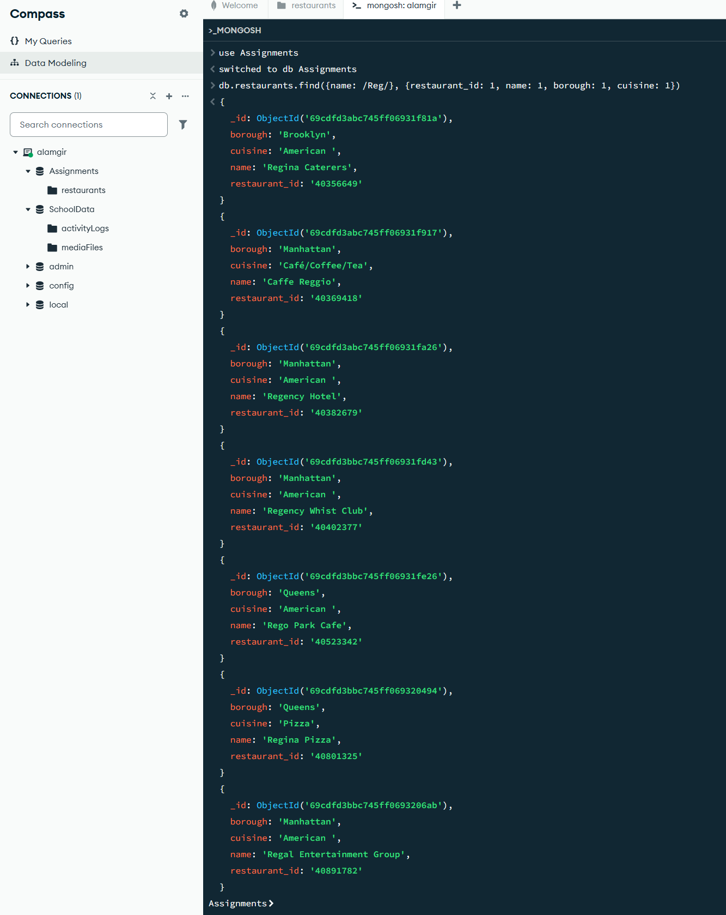

- Write a MongoDB query to find the restaurants which belong to the borough Bronx and prepared either American or Chinese dish.
db.restaurants.find({borough: "Bronx", $or: [{cuisine: "American "}, {cuisine: "Chinese"}]})
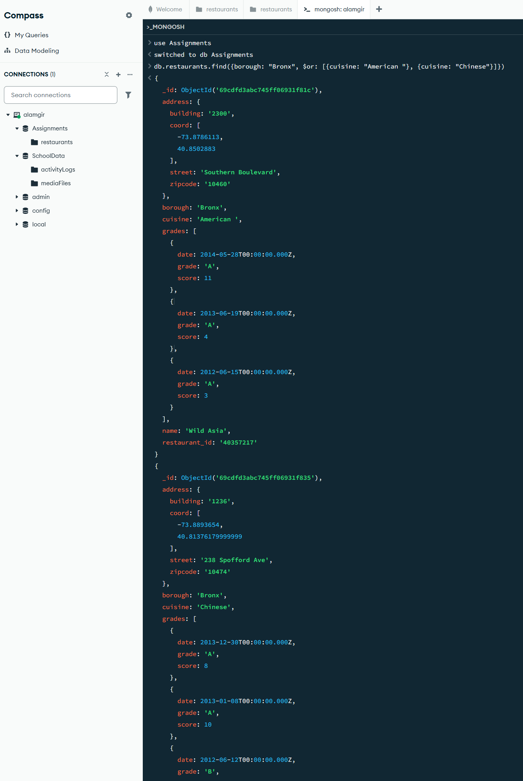
- Write a MongoDB query to find the restaurant Id, name, borough and cuisine for those restaurants which belong to the borough Staten Island or Queens or Bronxor Brooklyn.
db.restaurants.find({borough: {$in: ["Staten Island", "Queens", "Bronx", "Brooklyn"]}}, {restaurant_id: 1, name: 1, borough: 1, cuisine: 1})
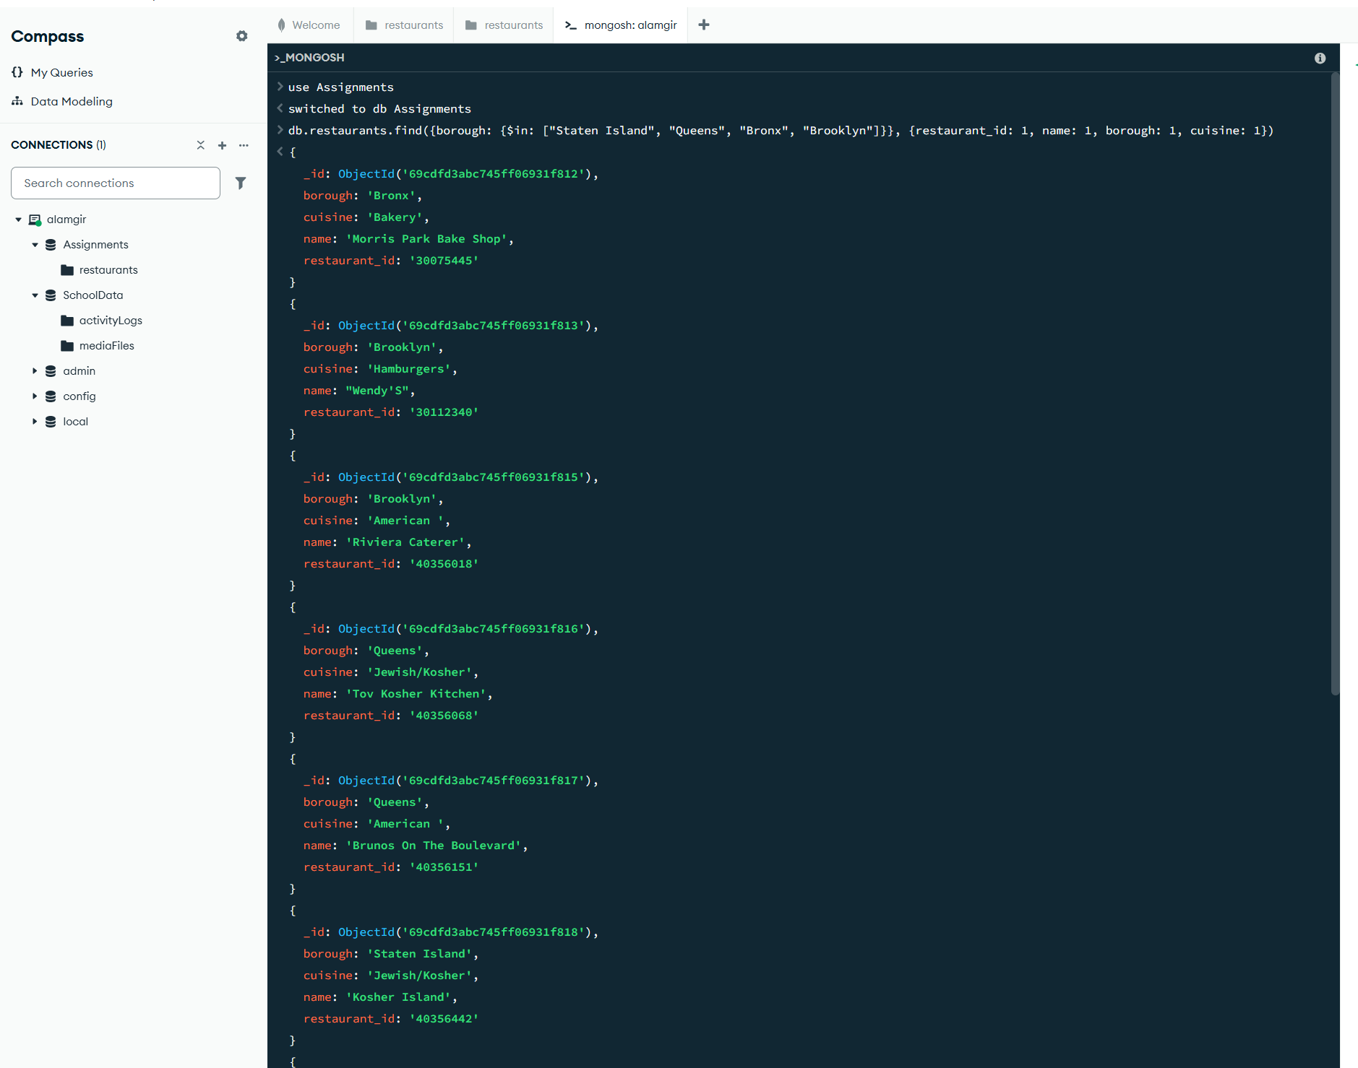

- Write a MongoDB query to find the restaurant Id, name, borough and cuisine for those restaurants which do not belong to the borough Staten Island or Queens or Bronxor Brooklyn.
db.restaurants.find({borough: {$nin: ["Staten Island", "Queens", "Bronx", "Brooklyn"]}}, {restaurant_id: 1, name: 1, borough: 1, cuisine: 1})
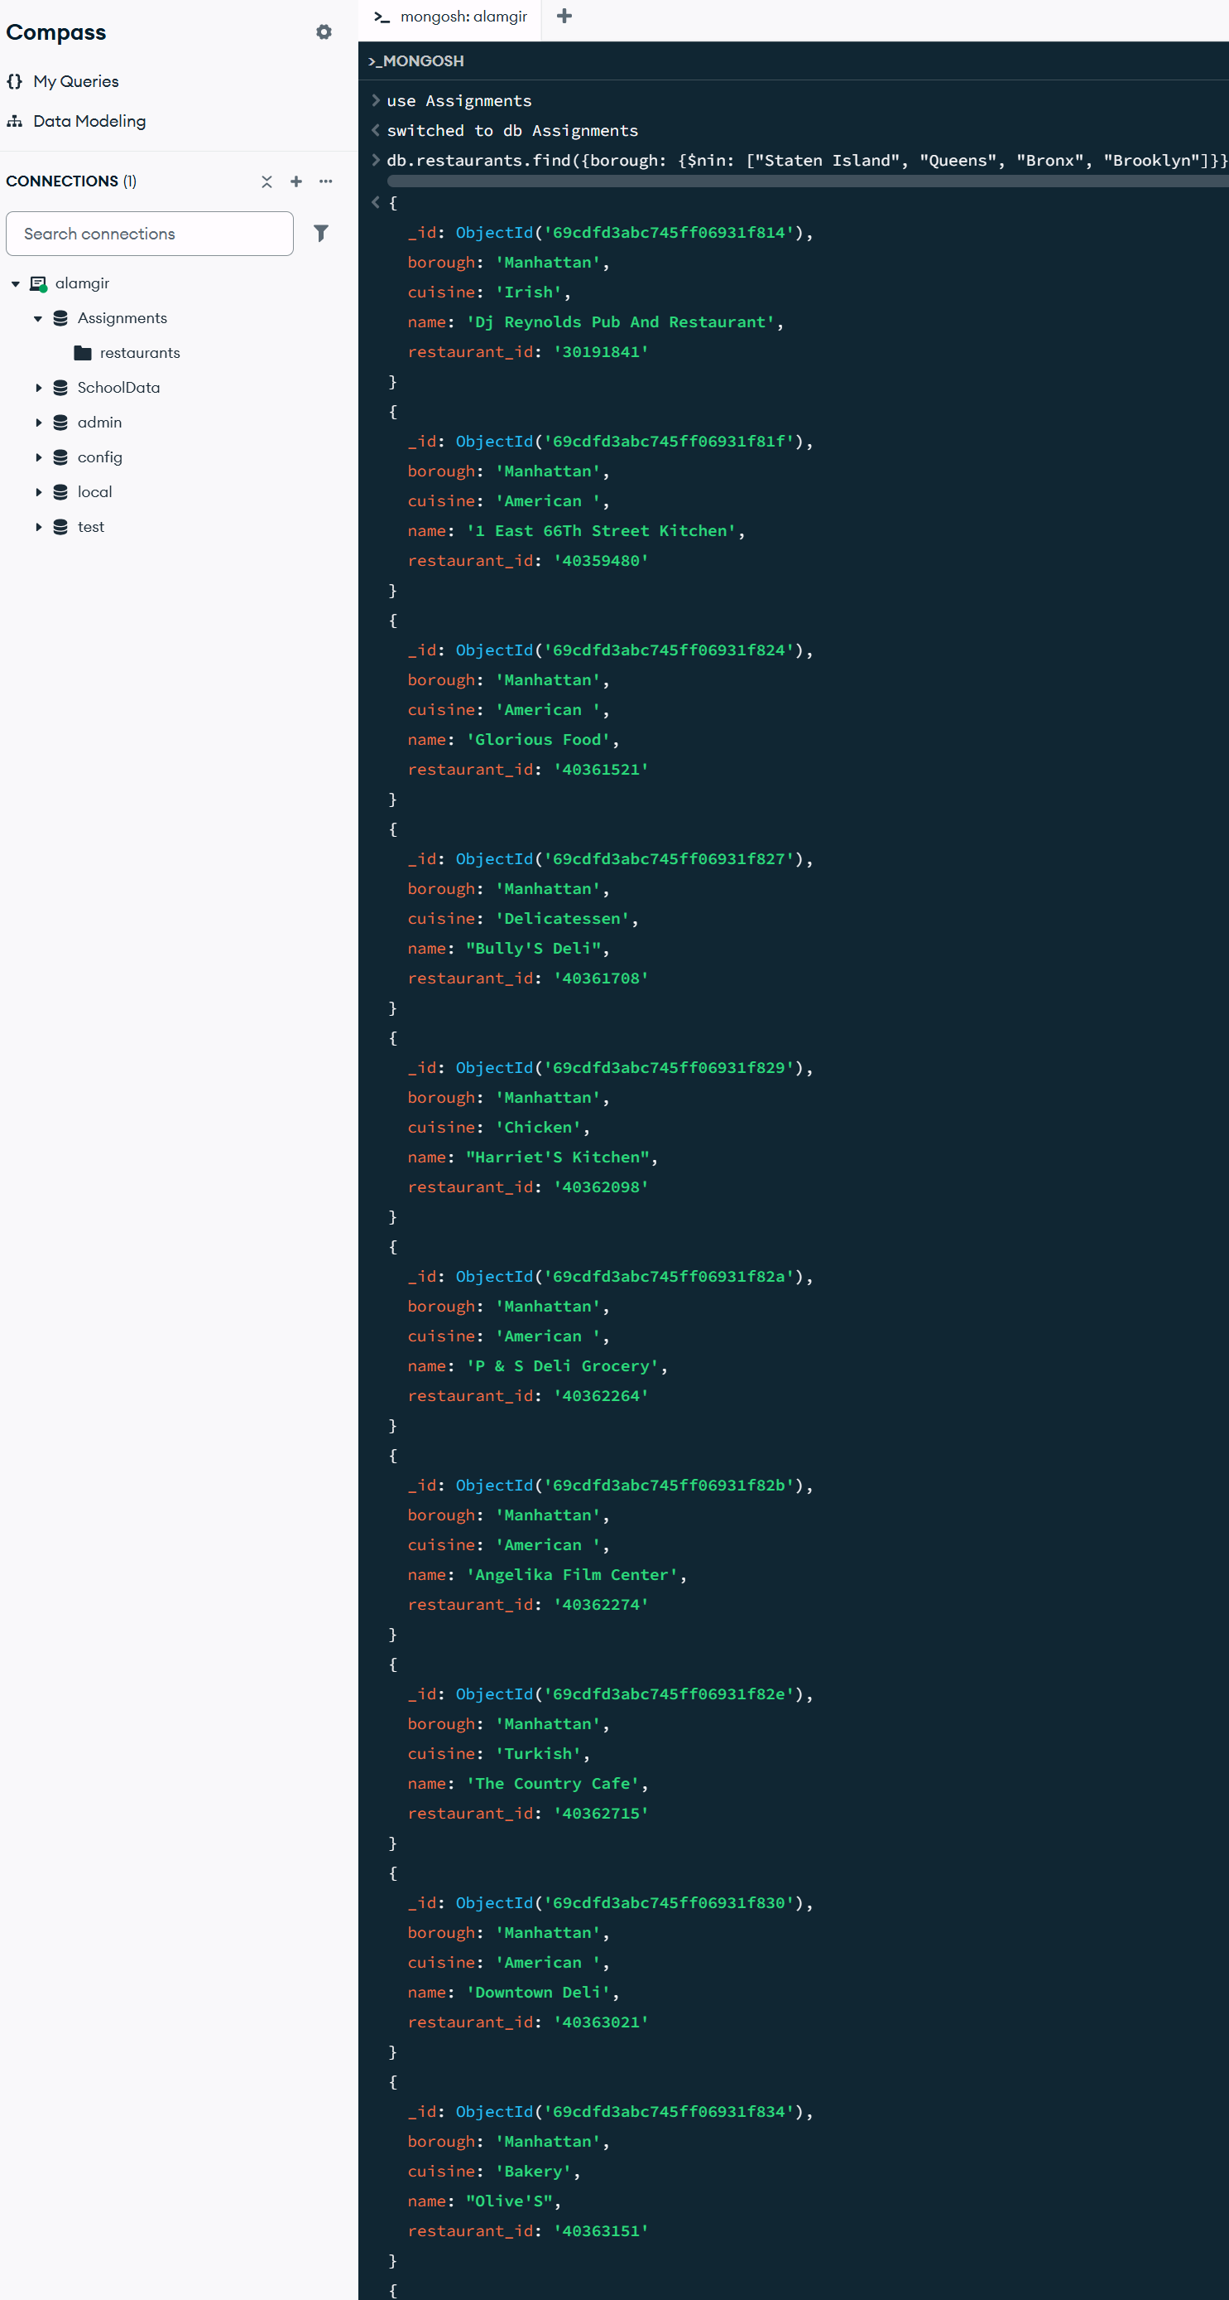

- Write a MongoDB query to find the restaurant Id, name, borough and cuisine for those restaurants which achieved a score which is not more than 10.
db.restaurants.find({"grades.score": {$lte: 10}}, {restaurant_id: 1, name: 1, borough: 1, cuisine: 1})
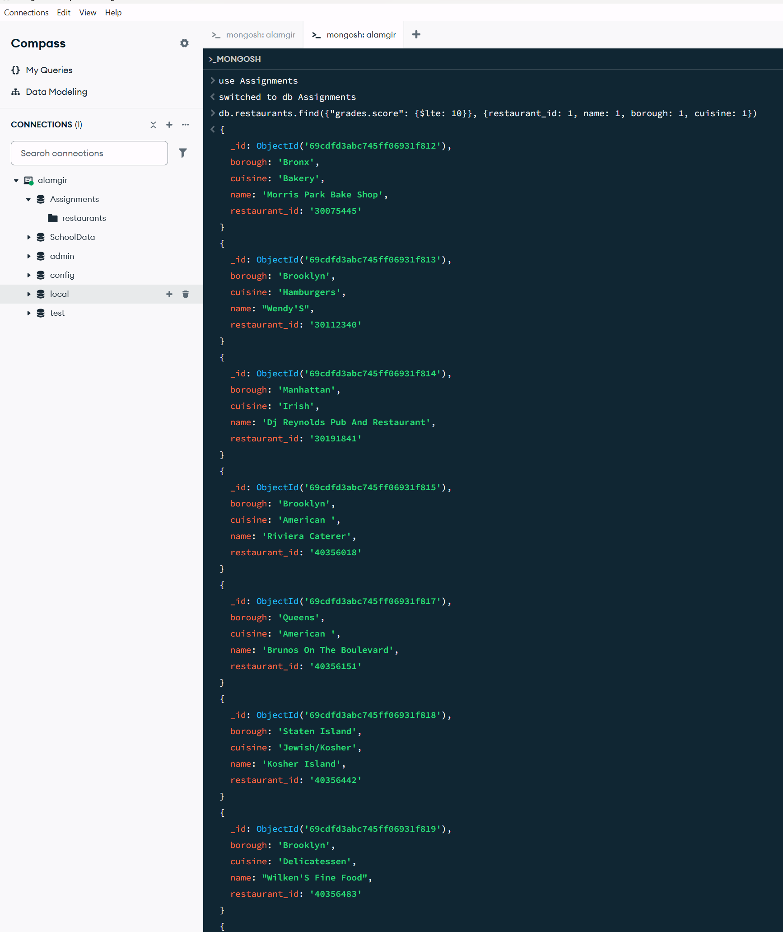
- Write a MongoDB query to find the restaurant Id, name, borough and cuisine for those restaurants which prepared dish except 'American' and 'Chinees' or restaurant's name begins with letter 'Wil'
db.restaurants.find({$or: [{cuisine: {$nin: ["American ", "Chinese"]}}, {name: /^Wil/}]}, {restaurant_id: 1, name: 1, borough: 1, cuisine: 1})

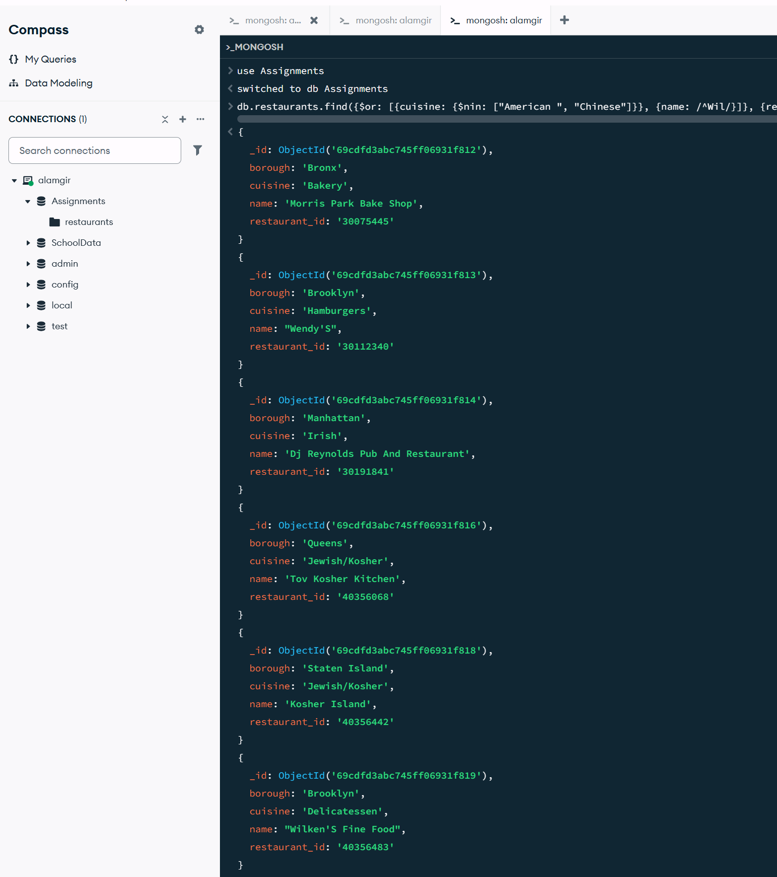

Part B: Array and Date Queries
- Write a MongoDB query to find the restaurant Id, name, and grades for those restaurants which achieved a grade of "A" and scored 11 on an ISODate "2014-08-11T00:00:00Z" among many of survey dates.
db.restaurants.find({grades: {$elemMatch: {grade: "A", score: 11, date: ISODate("2014-08-11T00:00:00Z")}}}, {restaurant_id: 1, name: 1, grades: 1})
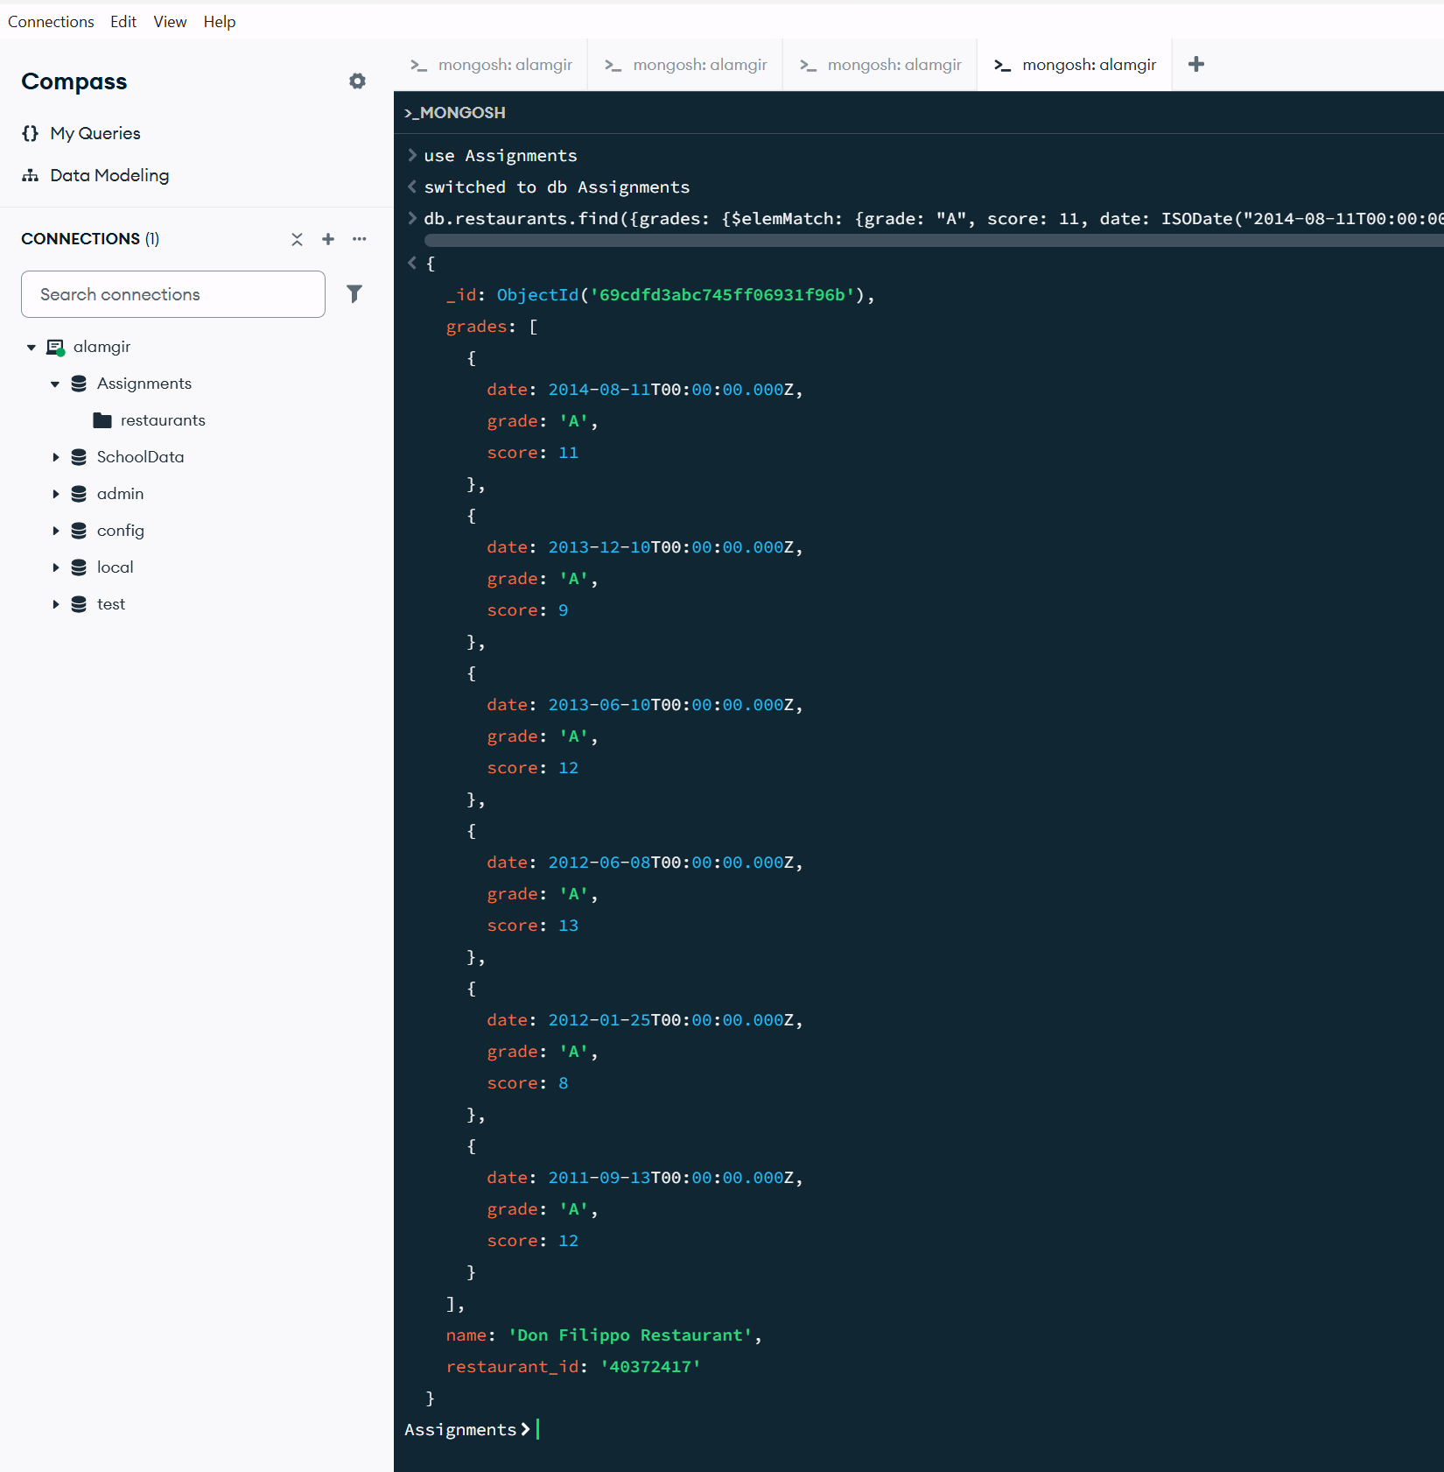

- Write a MongoDB query to find the restaurant Id, name and grades for those restaurants where the 2nd element of grades array contains a grade of "A" and score 9 on an ISODate "2014-08-11T00:00:00Z"
db.restaurants.find({"grades.1.grade": "A", "grades.1.score": 9, "grades.1.date": ISODate("2014-08-11T00:00:00Z")}, {restaurant_id: 1, name: 1, grades: 1})
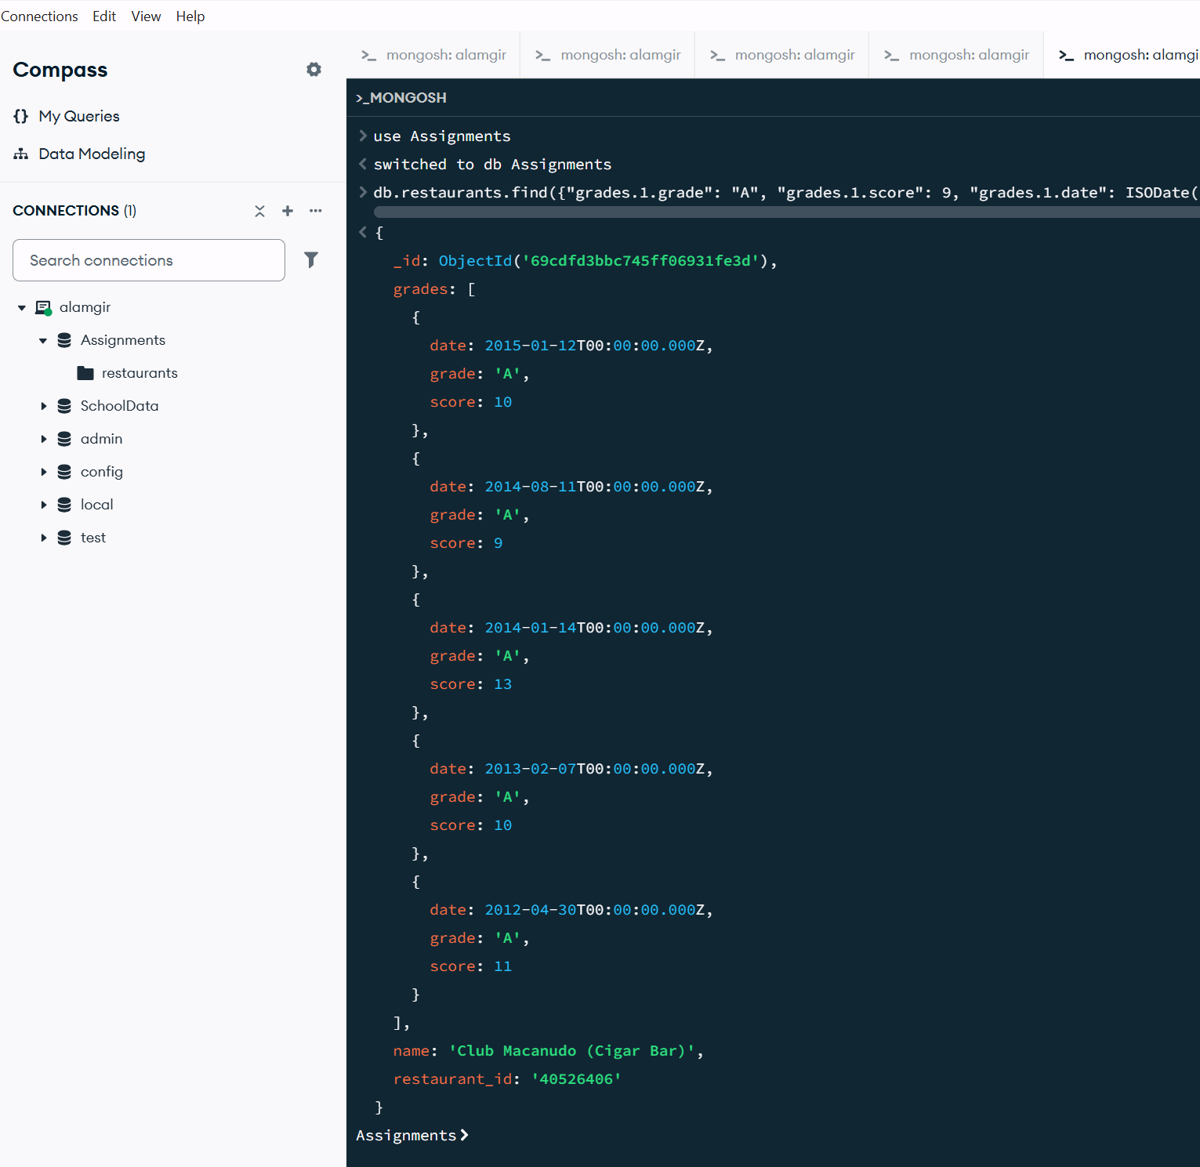

- Write a MongoDB query to find the restaurant Id, name, address and geographical location for those restaurants where 2nd element of coord array contains a value which is more than 42 and upto 52.
db.restaurants.find({"address.coord.1": {$gt: 42, $lte: 52}}, {restaurant_id: 1, name: 1, address: 1})
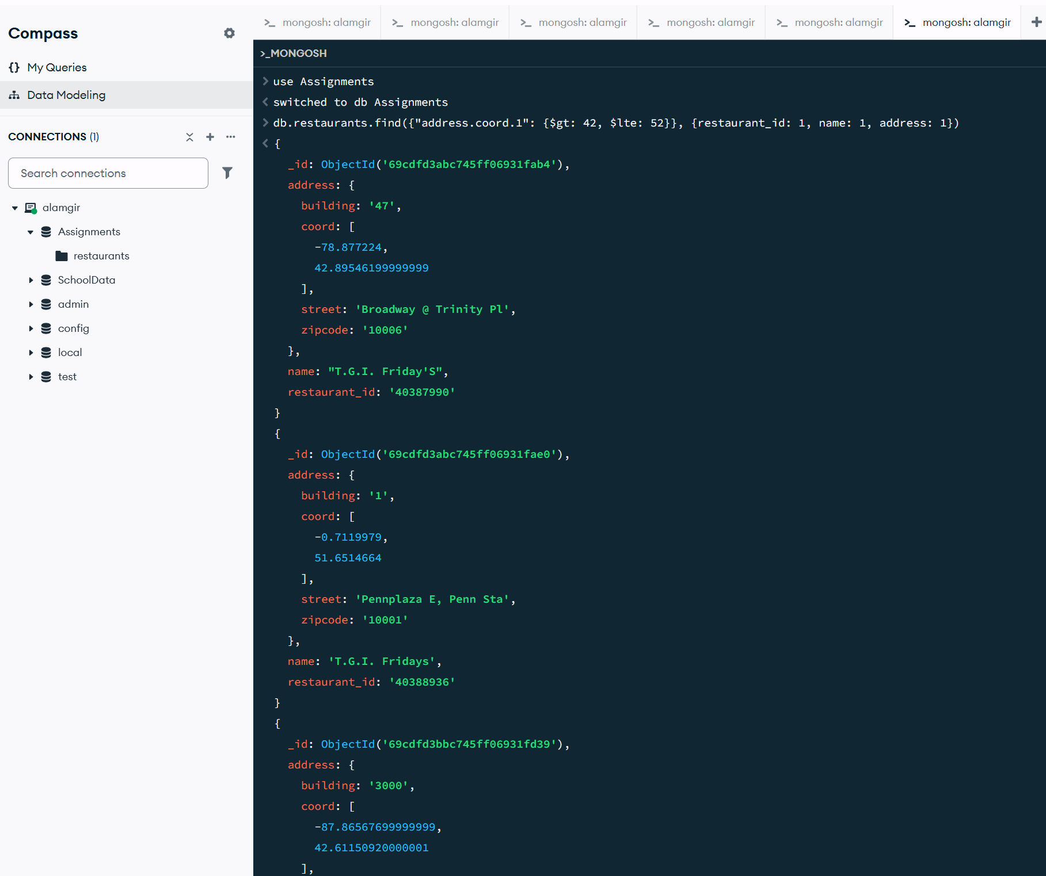

Part C: Sorting and Logical Queries
- Write a MongoDB query to arrange the name of the restaurants in ascending order along with all the columns.
db.restaurants.find().sort({name: 1})
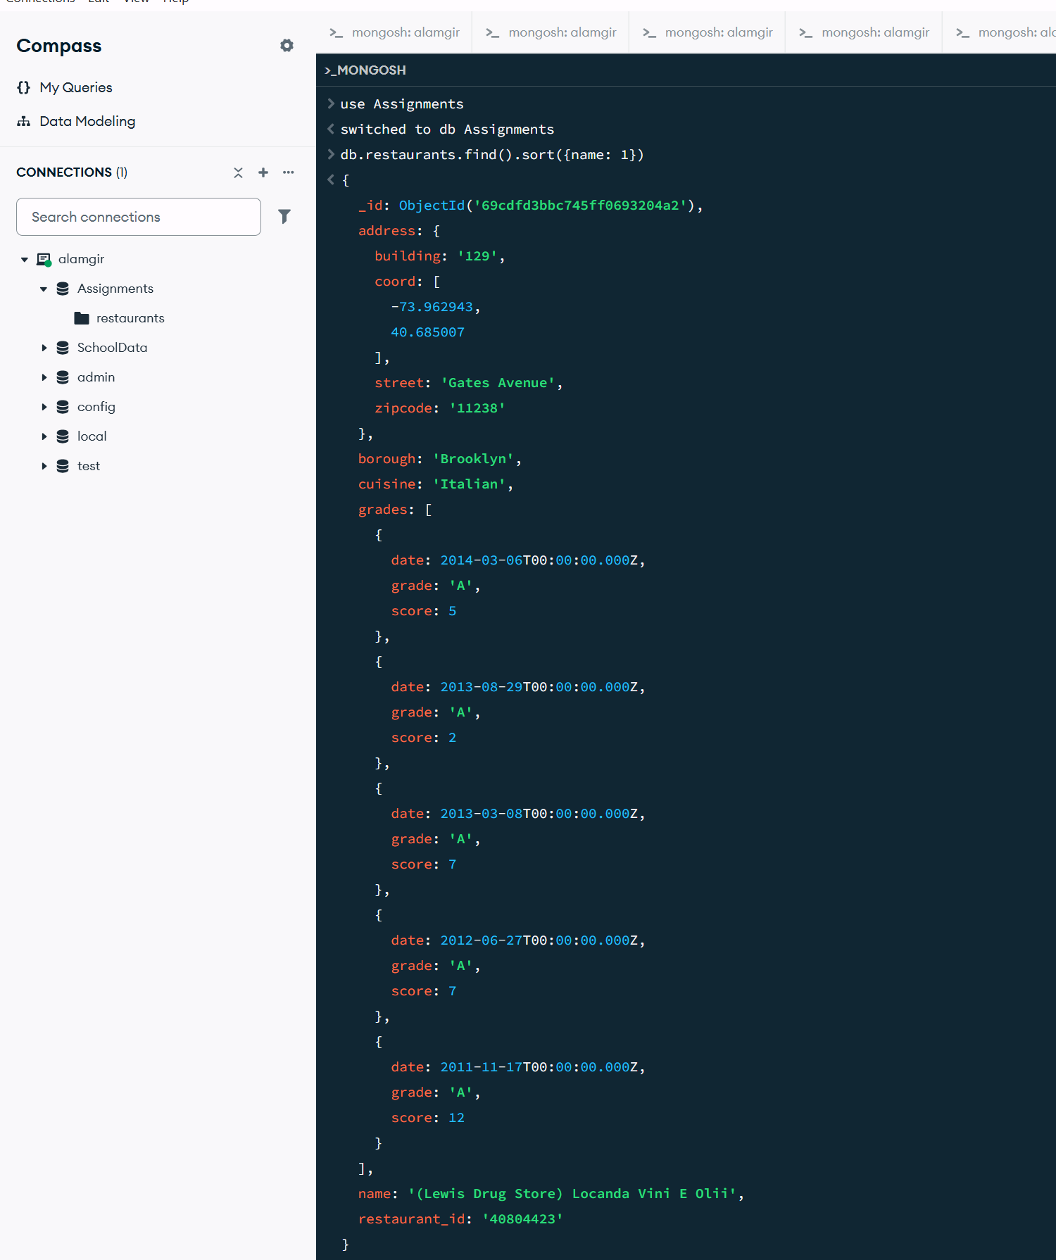

- Write a MongoDB query to arrange the name of the restaurants in descending along with all the columns.
db.restaurants.find().sort({name: -1})
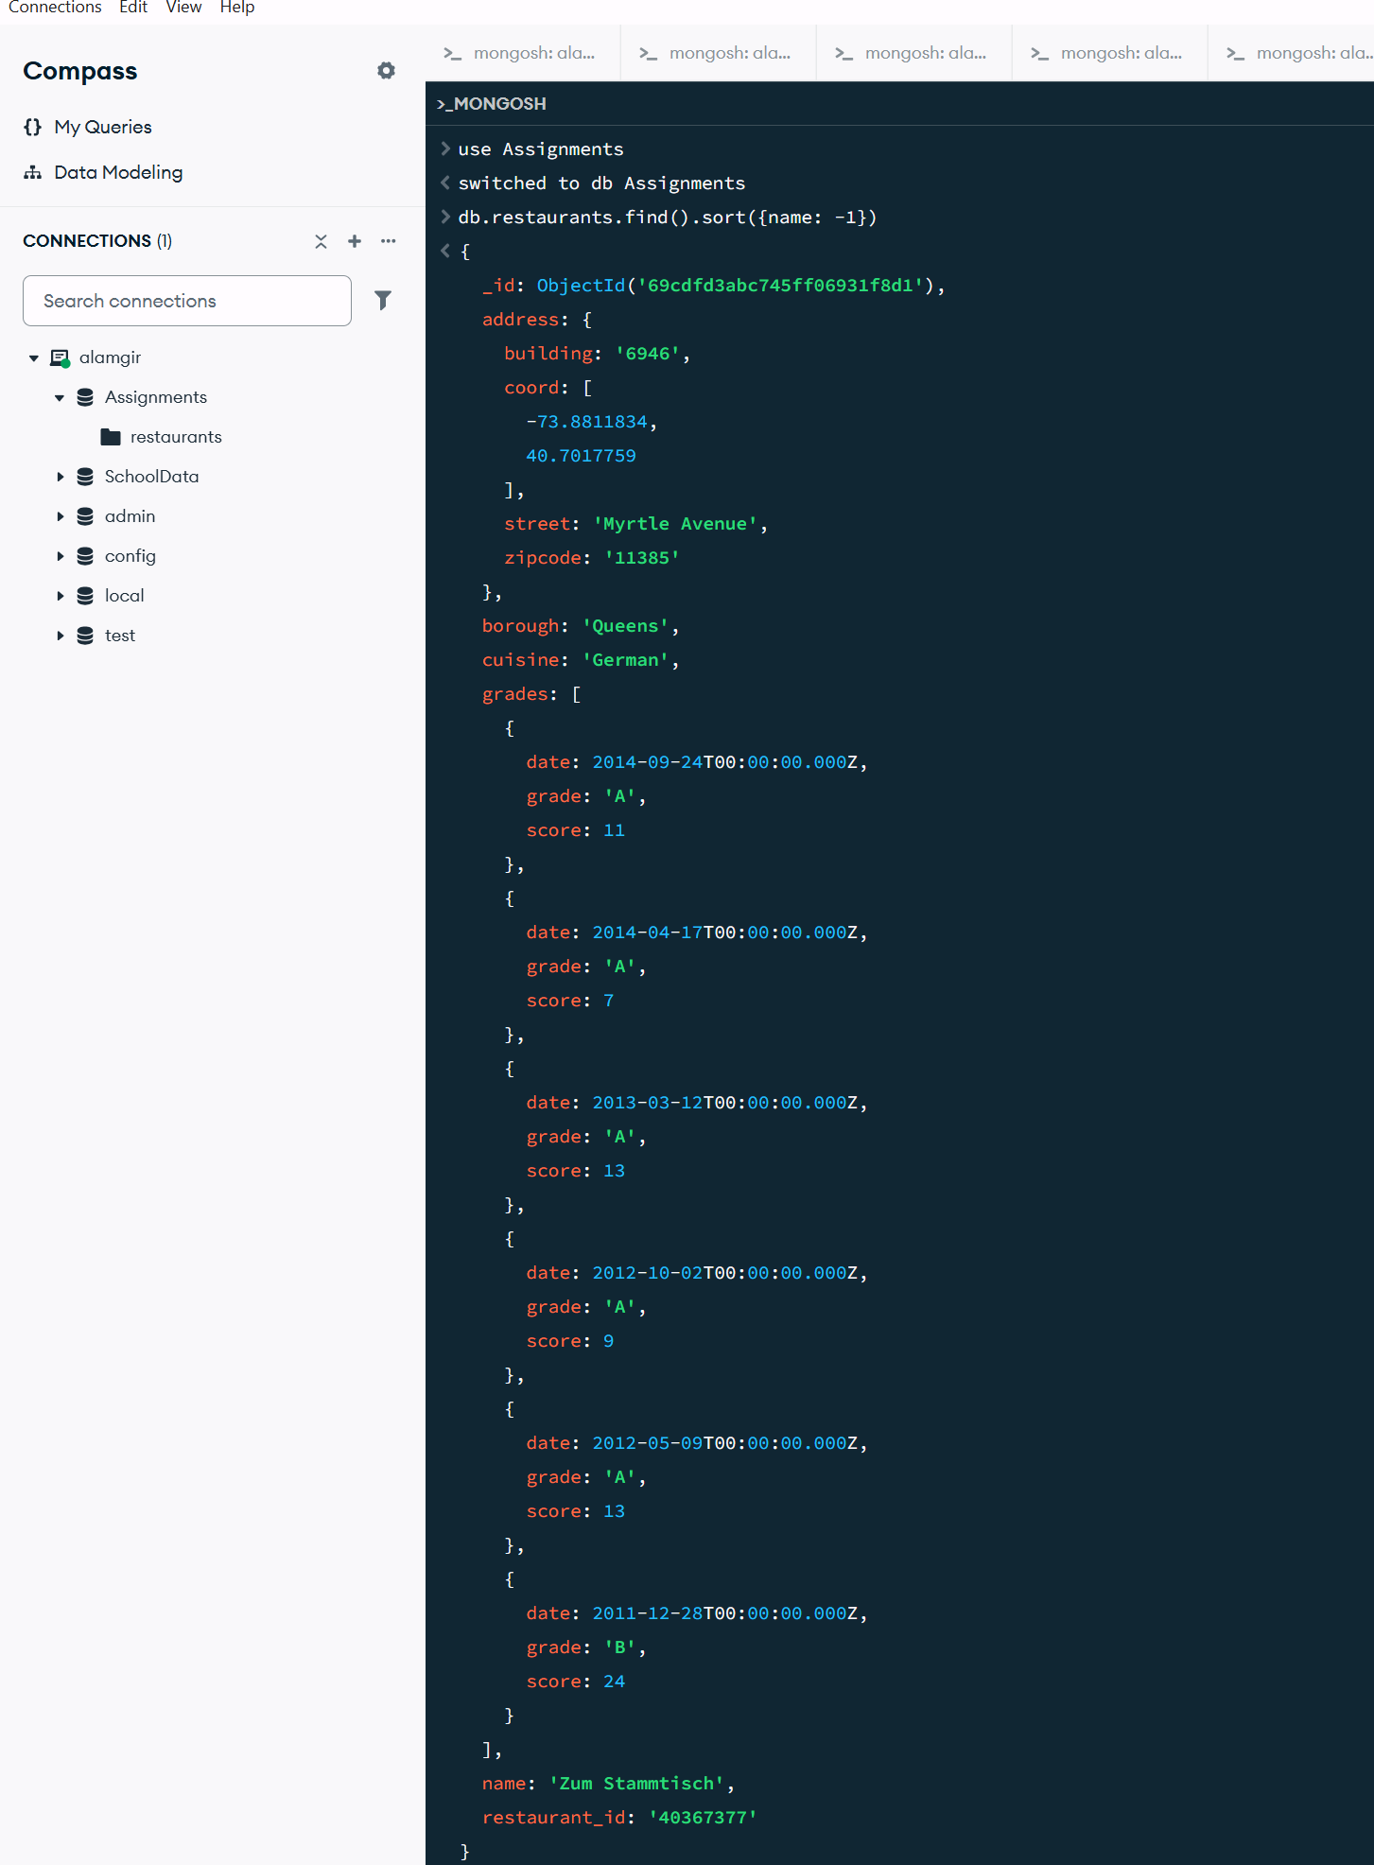

- Write a MongoDB query to arranged the name of the cuisine in ascending order and for that same cuisine borough should be in descending order.
db.restaurants.find().sort({cuisine: 1, borough: -1})
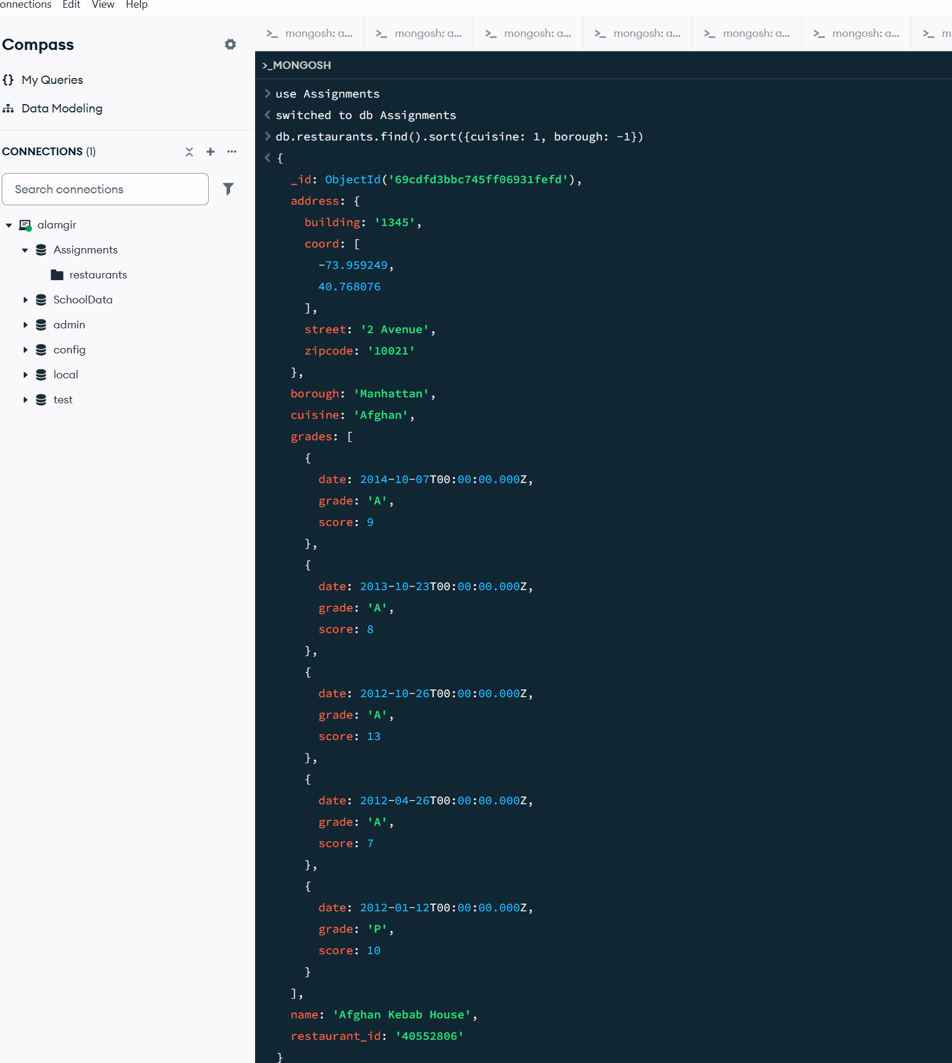

- Write a MongoDB query to know whether all the addresses contains the street or not.
db.restaurants.find({"address.street": {$exists: true}})
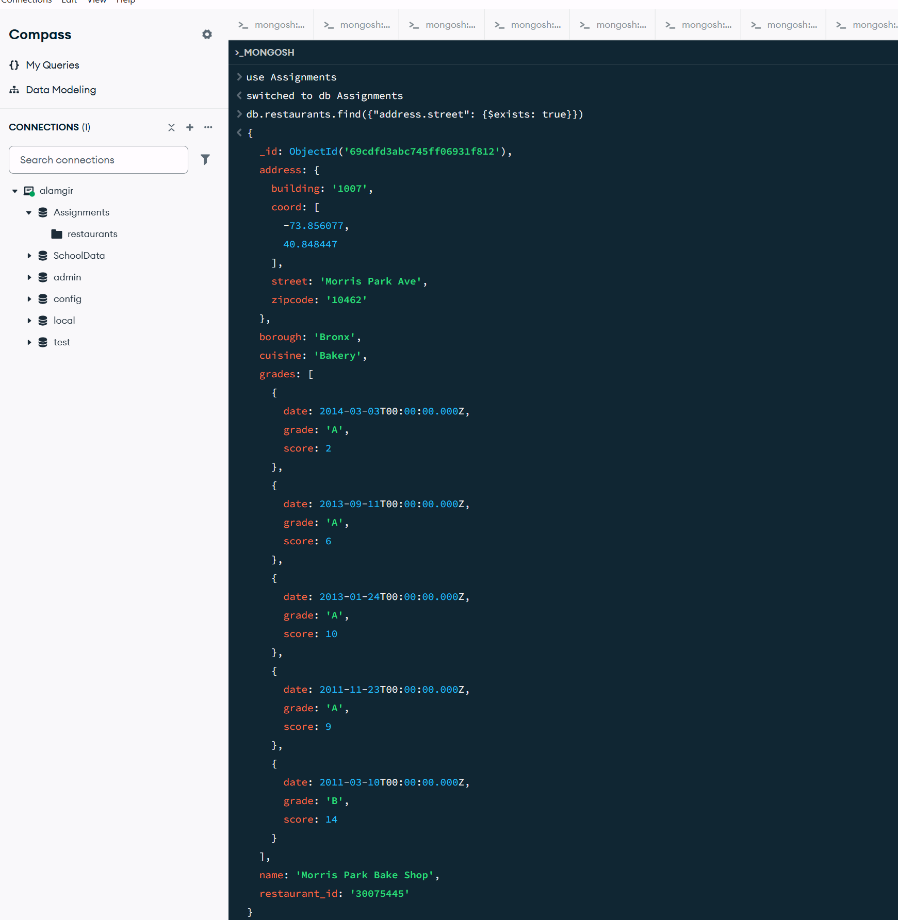

- Write a MongoDB query which will select all documents in the restaurants collection where the coord field value is Double.
db.restaurants.find({"address.coord": {$type: "double"}})
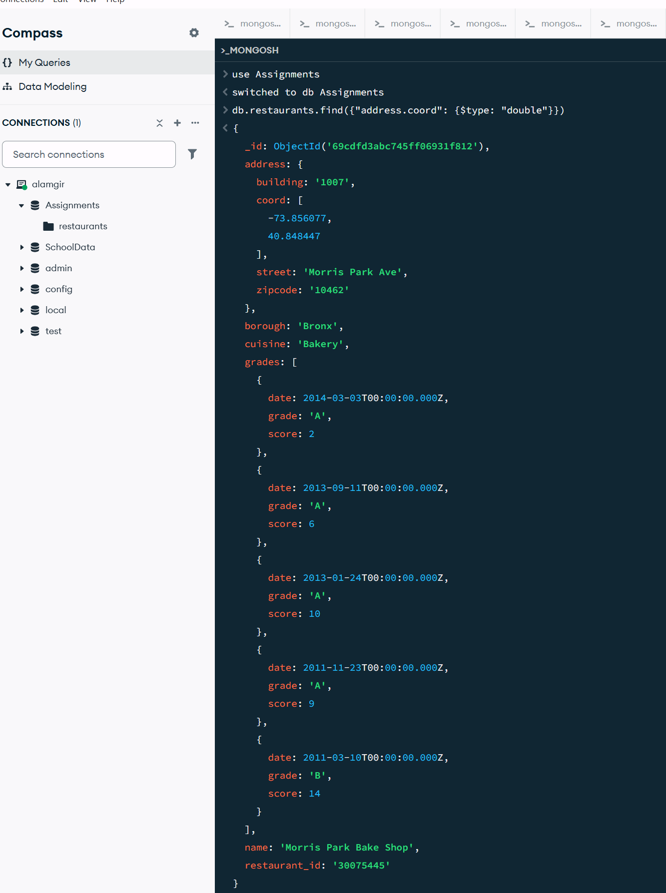
- Write a MongoDB query which will select the restaurant Id, name and grades for those restaurants which returns 0 as a remainder after dividing the score by 7.
db.restaurants.find({"grades.score": {$mod: [7, 0]}}, {restaurant_id: 1, name: 1, grades: 1})
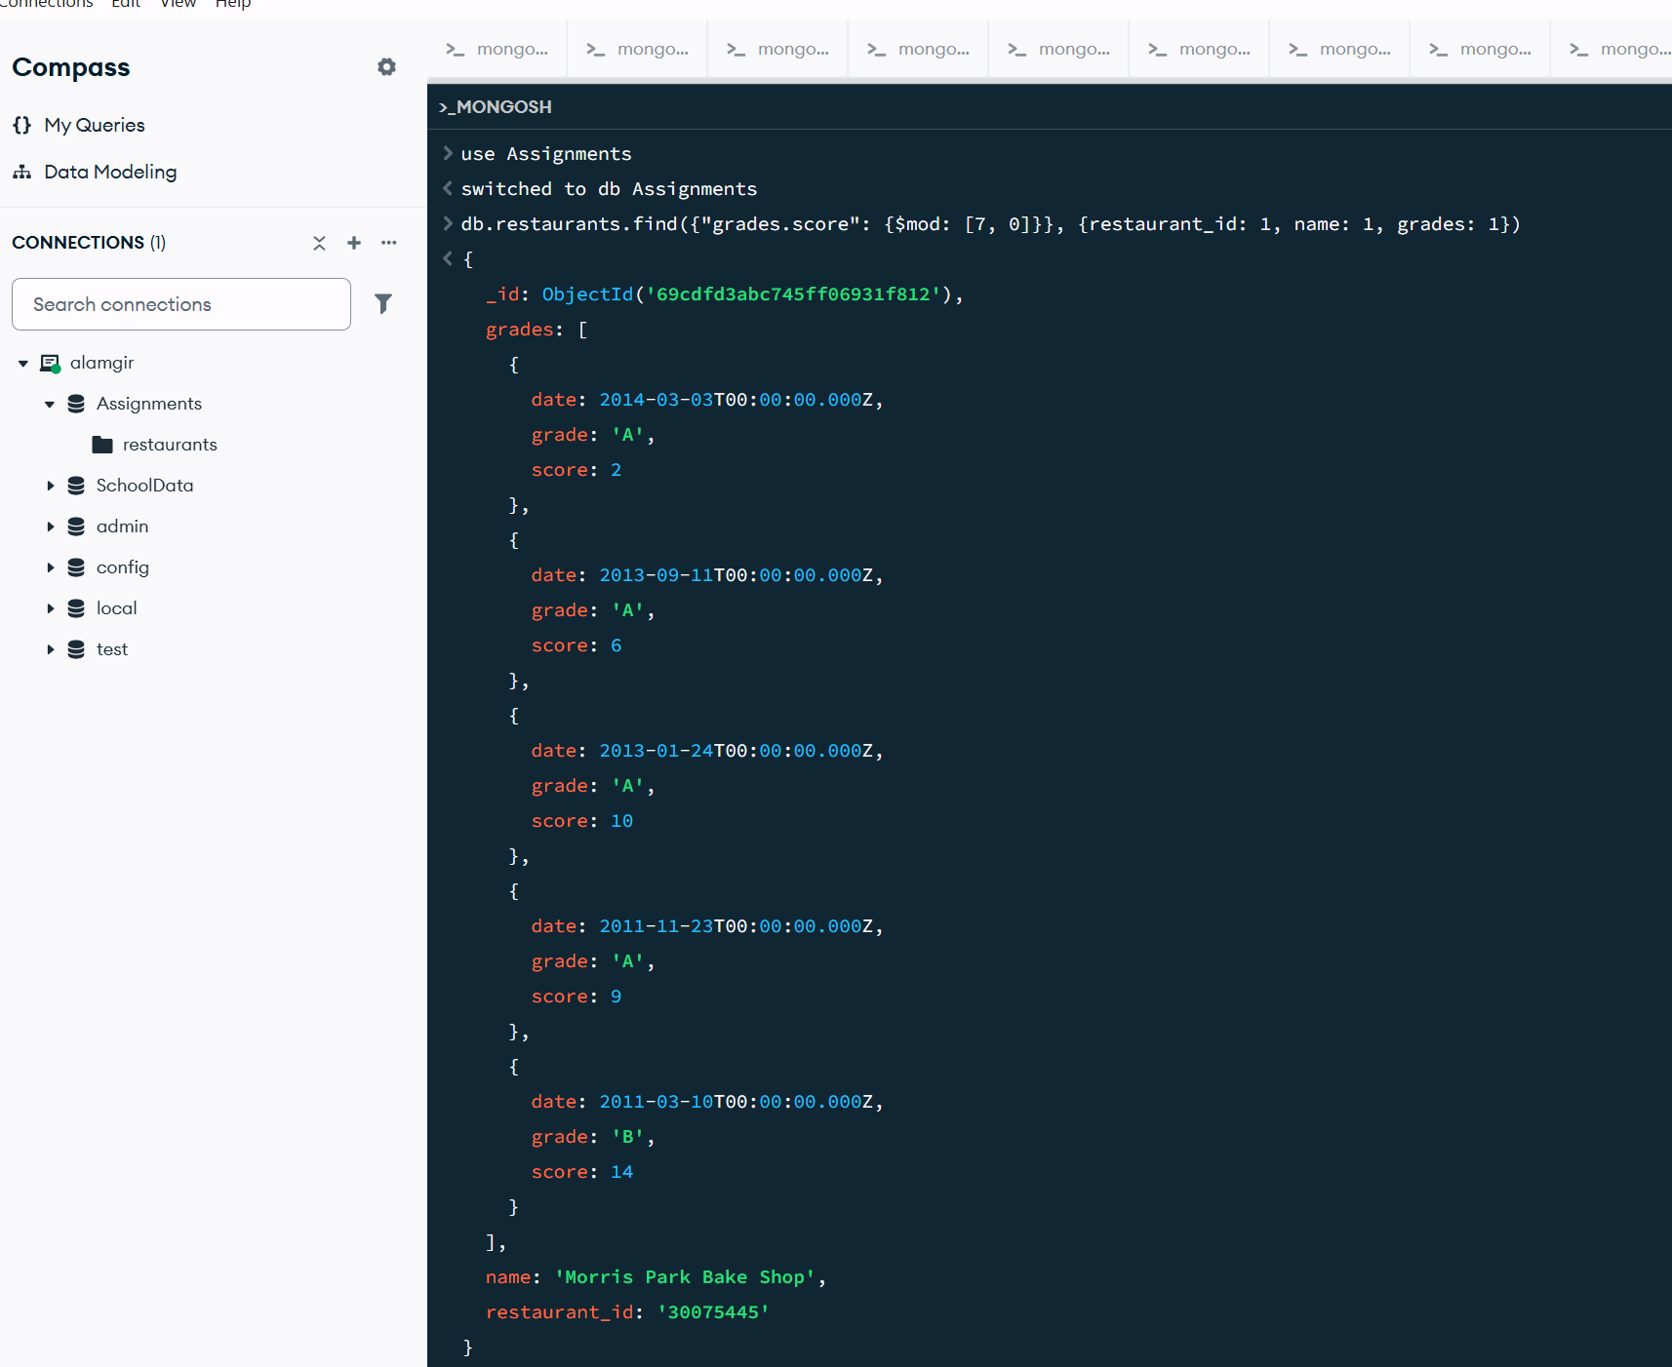

Part D: Specific Name Searches
- Write a MongoDB query to find the restaurant name, borough, longitude and attitude and cuisine for those restaurants which contains 'mon' as three letters somewhere in its name.
db.restaurants.find({name: /mon/}, {name: 1, borough: 1, "address.coord": 1, cuisine: 1})
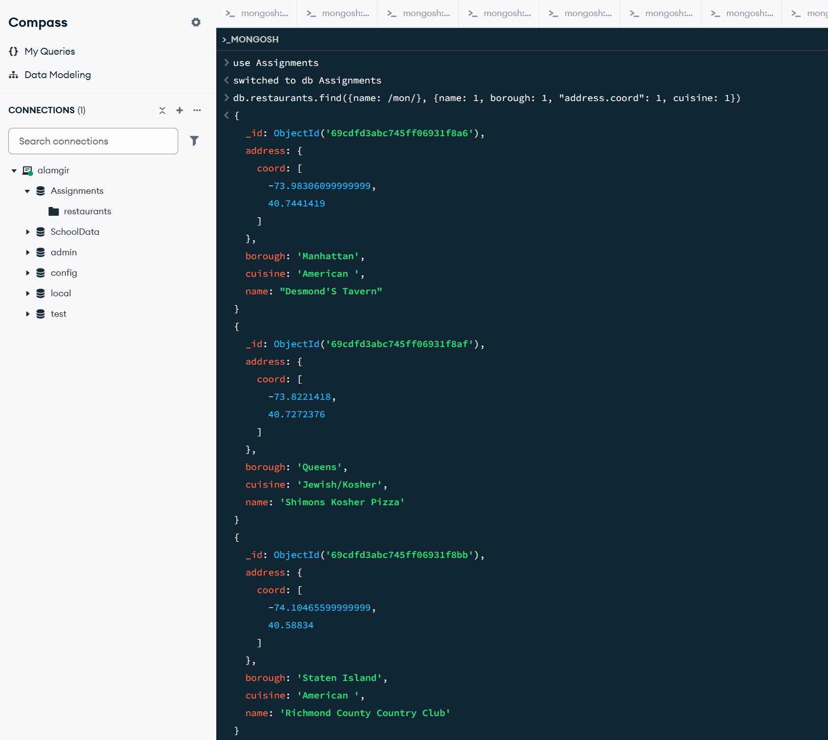

- Write a MongoDB query to find the restaurant name, borough, longitude and latitude and cuisine for those restaurants which contain 'Mad' as first three letters of its name.
db.restaurants.find({name: /^Mad/}, {name: 1, borough: 1, "address.coord": 1, cuisine: 1})


 

